Chapter 10
Entomopathogenic and Predacious Fungi

This chapter describes how some fungi act as parasites on host organisms and consume living invertebrates such as arthropods, insects, nematodes, or rotifers (e.g. Arthrobotrys oligospora). These fungi have developed specialized mechanisms for attracting and consuming these organisms and therefore play an important role in determining the soil ecology. Some of the parasitic fungi can even consume other fungi, acting as mycoparasites. When such fungi’s hosts are themselves parasites, they are known as hyperparasites (Ampelomyces quisqualis is an example of a fungal hyperparasite among members of the powdery mildews in the order Erysiphales). There are a growing number of biocontrol products available to Cannabis cultivators that contain entomopathogenic fungi that can be used to decrease pest pressure and may have other mechanisms for facilitating increased plant growth as well (Table 1).
Table 1. Commercially available biocontrol fungi that can act as bioinsecticides include Beauvaria bassiana, Metarhizium anisopliae, and Isaria fumosorosea.
Fungus | Product
Beauvaria bassiana | Mycotrol, Botanigard, Bioceres
Metarhizium anisopliae | Met 52, Met Master
Isaria fumosorosea | PFR-97, Ancora

Fungi can act as parasites or pathogens on pretty much every other form of eukaryotic life. One group of soil-borne and endophytic fungi, known as entomopathogenic fungi, will germinate spores when they come in contact with the proper insect body under favorable conditions. The hyphae will grow into the body of the insect, slowly digesting the insect's organs. Some entomopathogenic fungi are even able to hijack their host animal’s consciousness, forcing them to crawl to a the highest point available, so that the fungus can produce a spore bearing structure and disperse its spores to a larger range (e.g. Beauveria bassiana) .

Perhaps the most famous example of this is the fungus Opihocordyceps sinensis which infects the larval stage of ghost moths in the Himalayas (Fig. 1). Once the caterpillar is inoculated and fully colonized, the fungus produces a mushroom that sprouts directly out of the mummified corpse. This fungus is particularly notable for its use in Chinese medicine and is being researched in the US for its cytotoxic properties that may prove useful in the treatment of cancers (Yoshida et al 1989).
A commercially available entomopathogenic fungi that has utility to Cannabis farmers is the fungus Beauveria bassiana, the active ingredient in the products Mycotrol and Botanigard. This entomopathogenic fungus is able to live endophytically within a diversity of plant species, probably Cannabis among them. In this way it may act as a bioinsecticide, while at the same time controlling plant pathogens and promoting improved plant growth. This is a rather commonly encountered fungus found in soils, peat bogs, waterways, and birds nests throughout the world (Zimmerman 2007). Zimmerman also reports that B. bassiana has over 100 different insect hosts that it can infect. A related entomopathogenic fungus, Purpureocillium lilacinum, has been found as a common species occurring on California dispensary Cannabis (Thompson et al 2016). Both of these fungi are within the order Hypocreales, a clade characterized by members with parasitic lifestyles on insects, arthropods, plants, and even other fungi. The common edible fungi, the “lobster mushroom,” is actually a species of Russula or Lactifluus parasitized by Hypomyces lactifluorum.

Most entomopathogenic fungi that infect insects percutaneously (through cuticle) do so in four major steps: 1) Attachment of a spore or conidium to the insect body. 2) Spore germination. 3) Penetration through cuticle. 4) Outperforming host immune system. 5) Invasion of the host body by growing hyphae or producing conidia/spores. 6) Production of sporulating structure outside of mummified insect body (Zimmerman 2007).
Once the spore becomes attached to the insect cuticle, environmental and host cues initiate spore germination. As the germ tube forms into hyphae the fungus searches for weaker areas of the insect, such as joints or sockets. When a susceptible location is reached, the fungus forms an appressorium and penetration peg. Exoenzymes are released from the penetration peg to weaken the cell wall. These mechanisms allow for the physical penetration of the host body. Once inside the fungus must evade the host immune system. In response, the host mounts a defense by producing antifungal compounds, but the fungus can form hyphal bodies (which are superficially similar to yeast cells) able to spread throughout the host circulatory system. Once the insect is fully colonized and mummified by fungal hyphae, reproductive structures develop outside of the host's body in order to disperse to new fresh food resources in the form of new insect and arthropod victims (Zimmerman 2007).

Nematophagous fungi
There are also a number of fungi that can consume nematodes as a source of nutrients. Nematodes are ubiquitous in soil, water and in other decaying organic matter. In environments where nutrients are limiting, especially nitrogen (such as inside a downed log), there is intense competition amongst the inhabitants for their procurement. As a result, some fungi, referred to as nematophagous fungi, have evolved novel mechanisms for consuming nitrogen rich nematodes (Fig. 3). Nematodes provide a source of concentrated nitrogen and other nutrients, which the fungi may then directly absorb. This adaptation has evolved multiple times across different fungal lineages, an example of convergent evolutions.
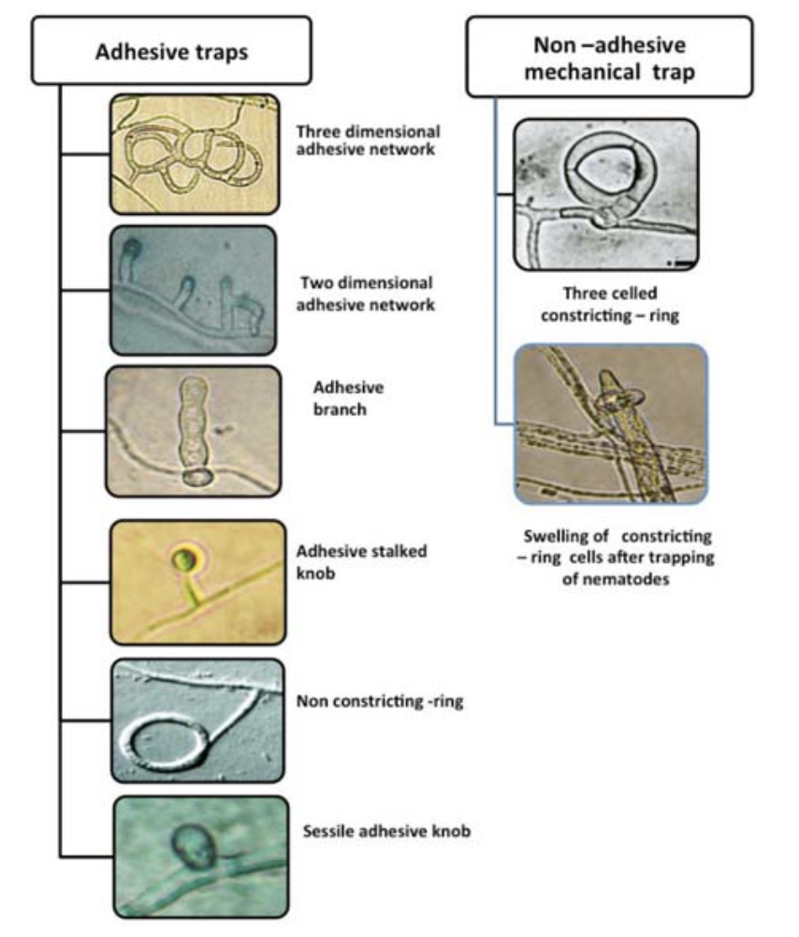
Figure 10.1 Examples of different types of traps that various fungi employ to lure and capture nematodes in soil. (Kumar 2017).

Nematophagous fungi are paraphyletic, meaning they are found in different phyla throughout the fungal kingdom representing different evolutionary origins. Many are imperfect soil fungi whose sexual state has not been observed, while others are grouped within the chytrids, ‘Zygomycetes,’ and even mushroom-producing Basidiomycetes -including members of the well known edible genera, Pleurotus (Marlin et al. 2019).
These carnivorous fungi have evolved different methods for acquiring nutrients from mobile nematodes. Some fungi produce conidia that are consumed by nematodes and, once inside, the fungal parasite germinates and consumes the animal from the inside out. Others produce physical structure in their hyphae such as hyphal loops that constrict on the wiggling nematode or a sticky peg that produces pheromones to attract the worm. Still others create a sort of mycelial net that can trap nematodes.
Gorfer et al. concluded that agricultural practices that increase soil carbon typically have increased fungal biomass, which leads to less nitrogen being lost from the system. Conversely, soils with little fungal biomass are more prone to leaching nitrogen off the farm (Gorfer et al. 2022). When fungi assimilate nitrogen and other nutrients and store it in their cells in the form of proteins or carbohydrates or other organic molecules, they become a prime food source for members of higher trophic levels in the soil food web. Fungal predators include nematodes, microarthropods, worms, birds, mammals and others.
As predators consume fungi, they excrete waste which can be in the form of plant available nutrients, thus propelling the nitrogen cycle and allowing other organisms to compete for them. Despite this propensity towards increasing nitrogen retention in soil, fungi may play complex and paradoxical roles in the cycling of nitrogen in soil systems. Fungi are able to transform various nitrogen containing molecules, contributing to all aspects in the nitrogen cycle, including the denitrification process. Certain soil fungi can metabolize nitrate and release nitrous gas in low oxygen environments (Hayatsu et al. 2008).

In summary:
- Some fungi have evolved to consume insects or other fungi
- Entomopathogenic fungi can be used as biocontrol to protect plants from insect pests

